TRIP BASED MODELLING OF FUEL CONSUMPTION IN

MODERN FLEET VECHILES USING MACHINE LEARNING

AN INDUSRTY ORIENTED MINI REPORT

Submitted to

# JAWAHARLAL NEHRU TECHNOLOGICAL UNIVERSITY, HYDERABAD

In partial fulfillment of the requirements for the award of the degree of

BACHELOR OF TECHNOLOGY

In

COMPUTER SCIENCE AND ENGINEERING

|  |  |
| --- | --- |
| Submitted by |  |
| RAMYA SREE KASULA  AKHIL BOINAPELLI  MANIKANTA CHELAMALLA  KOUSHIK BHUKYA    Under the esteemed guidance of | 21UK1A0523  21UK1A0521  21UK1A0559  22UK5A0502 |

Mr. Ch. Shivasai Prasad

Assistant Professor



DEPARTMENT OF COMPUTER SCIENCE AND ENGINEERING

VAAGDEVI ENGINEERING COLLEGE

(Affiliated to JNTUH, Hyderabad)

Bollikunta, Warangal (TS)– 506005

DEPARTMENT OF COMPUTER SCIENCE AND ENGINEERING

VAAGDEVI ENGINEERING COLLEGE



CERTIFICATE OF COMPLETION

INDUSTRY ORIENTED MINI PROJECT

This is to certify that the UG Project Phase-1 entitled “TRIP BASED MODELING OF

FUEL CONSUMPTION IN MODERN FLEET VEHICLES USING MACHINE LEARNING” is being submitted by RAMYA SREE KASULA(21UK1A0523),AKHIL BOINAPELLI(21UK1A0521),MANIKANTA CHELAMALLA(21UK1A0559),KOUSHIK

BHUKYA(22UK5A0502) in partial fulfilment of the requirements for the award of the degree of Bachelor of Technology in Computer Science & Engineering to Jawaharlal Nehru Techno-

logical University Hyderabad during the academic year 2024-2025

Project Guide HOD

Mr.Ch.Shivasai Prasad Dr. R. Naveen Kumar

(Assistant Professor) (Professor)

External

# ACKNOWLEDGEMENT

We wish to take this opportunity to express our sincere gratitude and deep sense of respect to our beloved Dr. SYED MUSTHAK AHAMED, Principal, Vaagdevi Engineering College for making us available all the required assistance and for his support and inspiration to carry out this Mini Project in the institute.

We extend our heartfelt thanks to Dr. R. NAVEEN KUMAR, Head of the Department of CSE, Vaagdevi Engineering College for providing us necessary infrastructure and thereby giving us freedom to carry out the Mini Project.

We express heartfelt thanks to Smart Bridge Educational Services Private Limited, for their

constant supervision as well as for providing necessary information regarding the Mini Project

and for their support in completing the Mini Project.

We express heartfelt thanks to the guide, Mr. Ch. Shivasai Prasad, Assistant professor, Department of CSE for his constant support and giving necessary guidance for completion of this Mini Project. Finally, we express our sincere thanks and gratitude to my family members, friends for their encouragement and outpouring their knowledge and experience throughout the thesis.

RAMYA SREE KASULA (21UK1A0523)

AKHIL BOINAPELLI (21UK1A0521)

MANIKANTA CHELAMALLA (21UK1A0559)

KOUSHIK BHUKYA (22UK5A0502)

ABSTRACT

The transportation industry is one of the largest and most important industries in the modern economy. Organizations in this industry operate more than a thousand fleet vehicles on average. Thus it becomes harder for organizations to manage the expenditures of the vehicles. The goal of this project is to provide a platform for users like individuals and organizations, which allows them to predict the fuel consumption of vehicles using Machine Learning. The project consists of two prediction sections, one for single-sample prediction and the other for multi-sample prediction. This allows organizations to manage expenditures and prevent fraudulent activities easily. This project is also designed to be highly extensible, which allows developers to use these features in their applications. A sample Excel sheet is provided, on which the user can enter multiple vehicle details and upload them to find the fuel consumption of all the vehicles in the Excel sheet. Users can also view their prediction history. The project also allows users to download detailed reports of the vehicles, which enables more detailed insight into the performance of the vehicles. Therefore it becomes easy to manage the fuel expenses for any organization or individual thus making it a better platform to use.

TABLE OF CONTENTS: -

1. INTRODUCTION ................................................................................6
   1. OVERVIEW………………………..……………………….……….. 6
   2. PURPOSE….….…………….……………………...…………………6
2. LITERATURE SURVEY….……………….…………………………7
   1. EXISTINGP ROBLEM……..……………………….………………..7
   2. PROPOSED SOLUTION…..………………….…..………….………7
3. THEORITICAL ANALYSIS ………….…………………..……….8-9
   1. BLOCK DIAGRAM…………………………………………………8
   2. HARDWARE / SOFTWARE DESIGNING …………….…………8-9
4. EXPERIMENTAL INVESTIGATIONS ……………..………...…10
5. FLOW CHART …………………………………………….…...……10
6. ADVANTAGES AND DISADVANTAGES…….…….………..…….11
7. CONCLUSION …………………..…………………………...………12

8.FUTURE SCOPE …………………………………..............................12

9. BIBILOGRAPHY ................................................................................ 13

10.APPENDIX……………………………………………..……….…14-37

11.RESULT ……………………………….……………………….......38-40

1.INTRODUCTION

1.1OVERVIEW

The fuel efficiency of fleet vehicles can be beneficial not only for the automotive and transportation industry but also for a country’s economy and the global environment . The cost of fuel consumed contributes to approximately 30% of a fleet vehicles life cycle cost. Reduction in fuel consumption by just a few percent can significantly reduce costs for the transportation industry . The effective and accurate estimation of fuel consumption (fuel consumed in L/km) can help to analyze emissions as well as prevent fuel-related fraud. As per Environmental Protection Agency (EPA) reports, 28% of total greenhouse gas emissions come from transportation (heavyduty vehicles and passenger cars) . The United States Environmental Protection Agency (US EPA) has introduced Corporate Average Fuel Economy (CAFÉ) standards enforcing automotive manufacturers to be compliant with standards to regulate fuel consumption . US EPA regulations enacting fuel economy improvements in freights released in 2016 target truck fuel efficiency, which is predicted to improve by 11–14% by 2021 . Most states have now mandated that truck fleets update their vehicle inventory with modern vehicles due to air quality regulation.

1.2 PURPOSE

Several studies have been presented in the past for evaluating the fuel efficiency of fleet vehicles using simulation-based models and data-driven models. A simulation model was developed based on engine capacity, fuel injection, fuel specification, aerodynamic drag, grade resistance, rolling resistance, and atmospheric conditions, with simulated dynamic driving conditions to predict fuel consumption . A statistical model which is fast and simple compared to the physical load-based approach was developed to predict vehicle emissions and fuel consumption . The impact of road infrastructure , traffic conditions , drivers’ behaviour , weather conditions , and the ambient temperature on fuel consumption were studied, and it was determined that fuel consumption can be reduced by 10% with eco-driving influences. The era of big data has enabled the modeling of huge volumes of data for companies to reduce emissions and fuel consumption.

Machine learning techniques such as support vector machine (SVM) , random forest (RF) , and IBM watson are widely applied to turn data into meaningful insights and solve complex problems.

2.LITERATURE SURVEY

2.1 EXISTING PROBLEM

Trip-based modeling of fuel consumption in modern fleet vehicles using machine learning addresses several existing problems:

1. Inefficient Fuel Use: Traditional methods may not capture the nuances of fuel consumption across different trips and driving conditions. This leads to inefficient fuel use and higher operational costs.
2. Lack of Real-time Insights: Fleet managers often lack real-time data and predictive insights, making it difficult to optimize routes and driving behaviors dynamically to save fuel.
3. Inaccurate Predictions: Existing models might not accurately predict fuel consumption due to insufficient consideration of factors like traffic conditions, driver behavior, vehicle load, and environmental conditions.
4. Scalability Issues: Manual data analysis and traditional modeling approaches can be cumbersome and do not scale well with large fleets, leading to less efficient management and decision-making processes.
5. Environmental Impact: Inefficient fuel consumption leads to higher emissions, contributing to environmental pollution and not meeting regulatory standards for emissions.
6. Maintenance and Wear: Inaccurate fuel consumption models can lead to poor maintenance scheduling, which affects vehicle health and longevity.

Using machine learning for trip-based fuel consumption modeling can provide more accurate predictions by analyzing vast amounts of data, considering multiple variables, and learning patterns that traditional methods may overlook. This leads to better fuel efficiency, cost savings, and a reduced environmental footprint.

2.2 PROPOSED SYSTEM

In order to solve the problems for the accuracy of the classification system, we proposed a new classification model. First, based on the pretrained models, the models were fine-tuned with the public dataset we used.

Based on their performance, the best model was selected in order to further adjust the performance for high accuracy in classifying ships in inland river waterways. After selecting the best model, the model was adjusted, and classification was conducted based on the modification of the network.

# 3.THEORETICAL ANALYSIS

3.1 BLOCK DIAGRAM

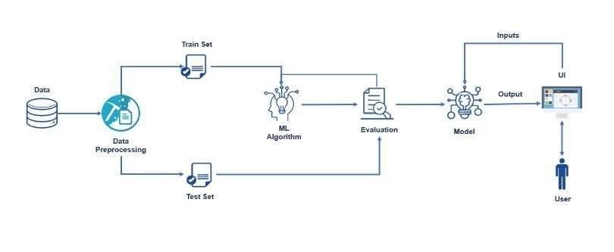

3.2. SOFTWARE DESIGNING AND HARDWARE

PYTHON:

Python is an interpreted, object-oriented, high-level programming language with dynamic semantics. It was created by Guido van Rossum , and first released on February 20, 1991. Its high-level built in data structures, combined with dynamic typing and dynamic binding , make it very attractive for Rapid Application Development, as well as for use as a scripting or glue language to connect existing components together. Python's simple, easy to learn syntax emphasizes readability and therefore reduces the cost of program maintenance. Python supports modules and packages, which encourages program modularity and code reuse. The Python interpreter and the extensive standard library are available in source or binary form without charge for all major platforms, and can be freely distributed.

ANACONDA NAVIGATOR:

Anaconda Navigator is a free and open-source distribution of the Python and R programming languages for data science and machine learning related applications. It can be installed on Windows, Linux, and mac OS.Conda is an opensource, cross platform, package management system. Anaconda comes with so very nice tools like JupyterLab, Jupyter Notebook, QtConsole, Spyder, Glueviz, Orange, Rstudio, Visual Studio Code. For this project, we will be using Jupyter notebook and Spyder.

JUPYTER NOTEBOOK:

The Jupyter Notebook is an open source web application that you can use to create and share documents that contain live code, equations, visualizations, and text. Jupyter Notebook is maintained by the people at Project Jupyter. Jupyter Notebooks are a spin-off project from the IPython project, which used to have an IPython Notebook project itself. The name, Jupyter, comes from the core supported programming languages that it supports: Julia, Python, and R. Jupyter ships with the IPython kernel, which allows you to write your programs in Python, but there are currently over 100 other kernels that you can also use.

FLASK:

Web framework used for building. It is a web application framework written in python which will be running in local browser with a user interface. In this application, whenever the user interacts with UI and selects emoji, it will suggest the best and top movies of that genre to the user.

HARDWARE REQUIREMENTS:

o Operating system: window7 and above with64bit o Processor Type -Intel Core i3-3220

o RAM: 4Gb and above

o Hard disk: min 100gb

# 4.EXPERIMENTAL INVESTIGATION

The text data need to be organized before proceeding with the project. The original dataset has a single folder. We will be using the measurements.csv file to fetch the text data of training data. The data need to be unique and all fields need to be filled. The dataset images are to be pre-processed before giving to the model. We will create a function that uses the pre-trained model for predicting custom outputs. Then we have to test and train the model. After the model is build, we will be integrating I to a web application.

# 5.FLOWCHART

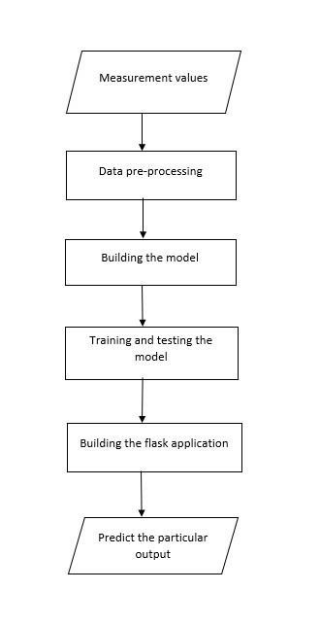

# 

# 6.ADVANTAGES AND DISADVANTAGES

ADVANTAGES:

1. Machine learning models can analyze vast amounts of data from various sources (e.g., GPS, sensors, historical data) to predict fuel consumption more accurately than traditional methods.
2. These models can process data in real-time, providing fleet managers with immediate insights into fuel consumption, enabling prompt decision-making.
3. Machine learning models can be tailored to individual vehicles and driving behaviors, allowing for more precise fuel consumption predictions.
4. By identifying patterns in fuel consumption data, machine learning can help predict when a vehicle might need maintenance, reducing downtime and improving overall efficiency.
5. Advanced algorithms can optimize routes and driving behaviors to minimize fuel consumption, thus reducing operational costs and environmental impact.

DISADVANTAGES:

1. High-quality, extensive datasets are crucial for training effective machine learning models. Incomplete or poor-quality data can lead to inaccurate predictions.
2. Developing and maintaining machine learning models can be complex and require specialized knowledge and skills, potentially increasing operational costs.
3. Machine learning models, especially deep learning, can be resource-intensive, requiring significant computational power and storage.
4. The initial cost of implementing machine learning solutions can be high, including costs for hardware, software, and skilled personnel.
5. Machine learning models, particularly deep learning models, can be seen as "black boxes" where the decision-making process is not easily interpretable, making it challenging to understand how specific predictions are made.

# 7.CONCLUSION

In conclusion, the study demonstrates the modeling of fuel consumption in modern fleet vehicles with an Machine Learning using very few technical parameters. An attempt was made to develop a model using very few parameters collected under different conditions. Data from modern fleet vehicles with the same make and model, driven by different persons on various routes under different external conditions, were used for training the Machine Learing.

# 8.FUTURE SCOPE

1. In future works, the proposed method will be improved in order to classify the people in different countries with extra features using more advanced technology.
2. Internet of Things (IoT): Integrating IoT devices to collect comprehensive data on various factors affecting fuel consumption.
3. Emissions Reduction: Developing models that not only predict fuel consumption but also optimize it to reduce emissions, contributing to environmental sustainability.
4. Predictive Maintenance: Using fuel consumption data to predict and prevent maintenance issues, ensuring vehicles operate efficiently.
5. Dashboards and Visualizations: Creating intuitive dashboards and visualization tools to help fleet managers understand and act on fuel consumption data.

# 9.BIBILOGRAPHY

1. Lin, W., & Qin, R. (2018). Vehicle Fuel Consumption Prediction Based on Machine Learning Algorithms. In 2018 IEEE International Conference on Big Data (Big Data) (pp. 4915-4917). IEEE.
2. Li, Y., Zhang, J., Yu, B., & Liu, X. (2019). Research on Predictive Model of Fuel Consumption for Vehicle Based on Machine Learning. In 2019 5th International Conference on Control, Automation and Robotics (ICCAR) (pp. 321-324). IEEE.
3. Yu, J., Ye, Z., & Yu, C. (2017). A hybrid fuel consumption model for commercial vehicles. Journal of Traffic and Transportation Engineering (English Edition), 4(3), 252-262.
4. Liao, Y., Xu, Q., Wang, S., Li, J., & Liu, C. (2019). Modeling and prediction of vehicle fuel consumption based on machine learning. Journal of Cleaner Production, 229, 597606.
5. Kim, K., Lee, J., & Jo, J. (2018). Prediction of Fuel Consumption for Vehicles Using Machine Learning. Energies, 11(11), 3162.
6. Khatami, A., Khatami, S., Akyel, C., & Balaban, E. (2019). A data-driven model for fuel consumption prediction in passenger cars. Energies, 12(15), 2961.

# 10.APPENDIX

SOURCE CODE:

## Import Required Libraries

Go to the project folder which you have created copy the project path and open anaconda prompt from the menu and go to the location of your project folder in anaconda prompt and type jupyter notebook. Now jupyter notebook will be opened and create a python file and start the programming.

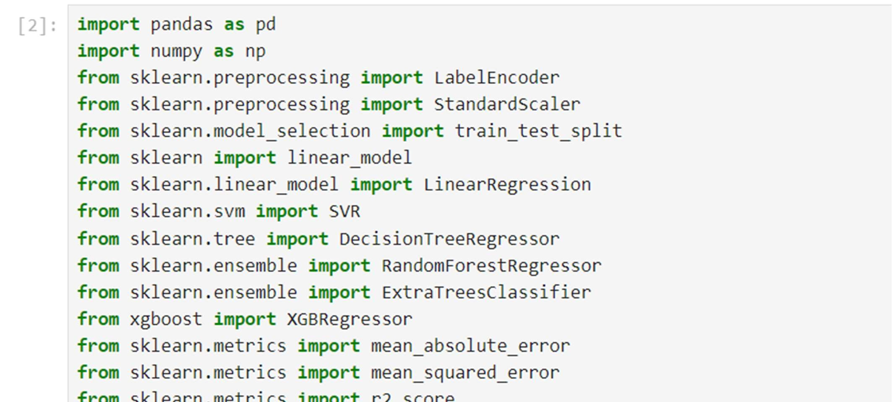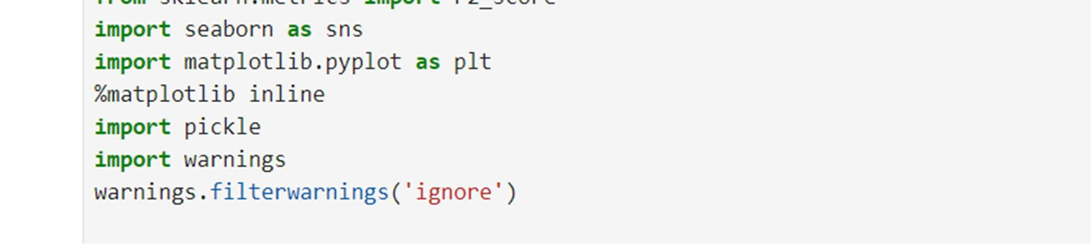

## Read The Datasets

The Our dataset format might be in .csv, excel files, .txt, .json, etc. We can read the dataset with the help of pandas.

In pandas, we have a function called read_excel() to read the dataset. As a parameter, we have to give the directory of xlsx file.

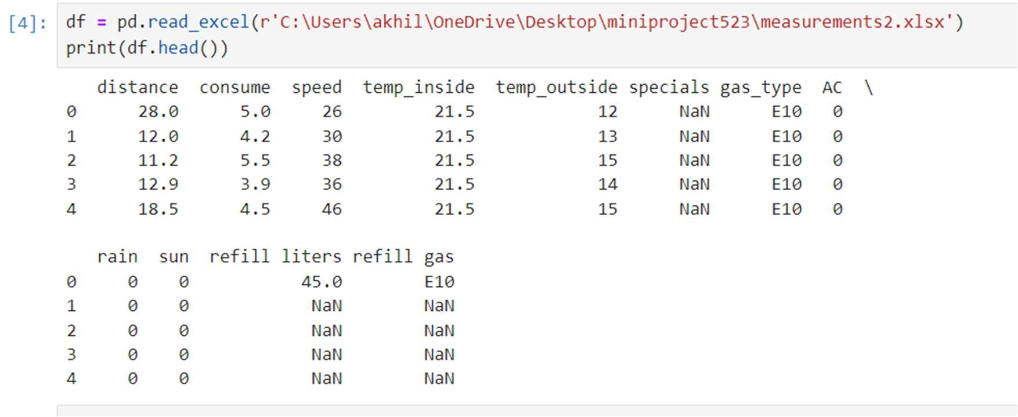

Check Null Values

For checking the null values, df.isnull() function is used. To sum those null values we use .sum() function to it. To visualize the null values heatmap() and barplot() from seaborn package is used.

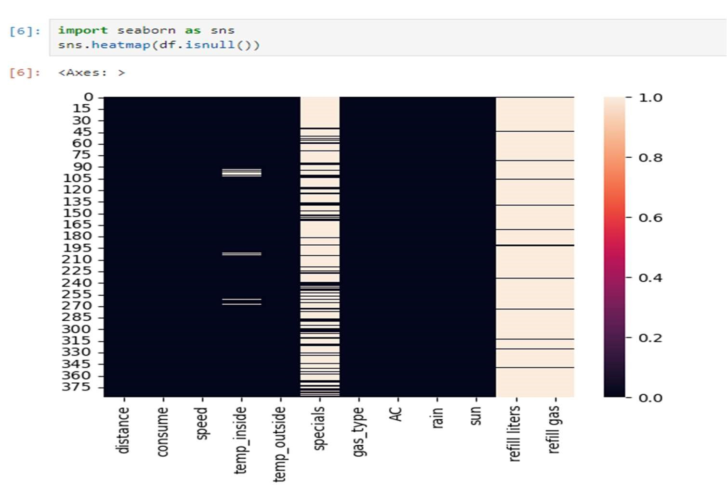

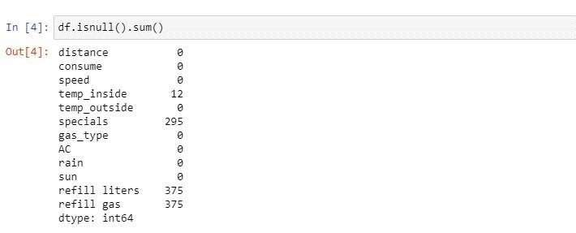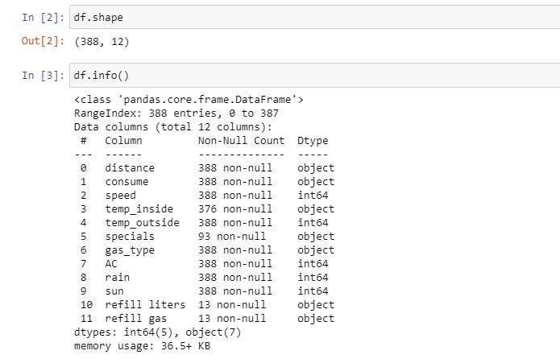

• Plotting the variables which consist of maximum no of null values.

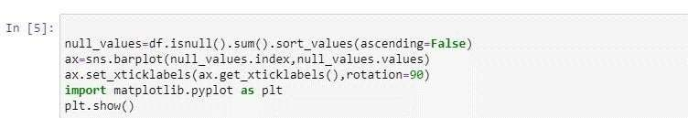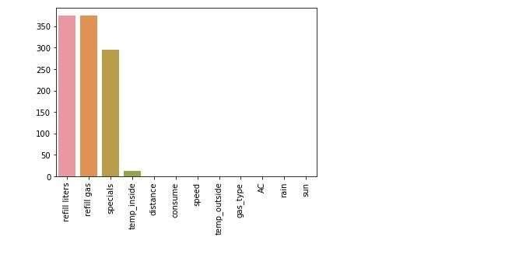

Removing Null Values

Refill gas, Refill liters, and specials columns are dropped using the drop() method from pandas. From the above image, we found these columns have many null values so it is dropped. Axis should be given as a parameter on the drop method.

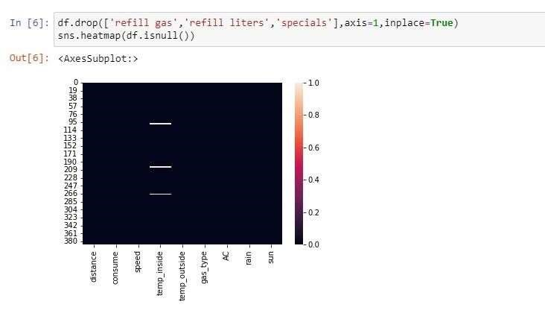

Handling Null Values

Here we are going to handle null values. From activity 3 we found we have null values in the ‘temp_inside’ column. So we are replacing the null value with its mean.

isnall() method from pandas is used to replace null values with their mean.

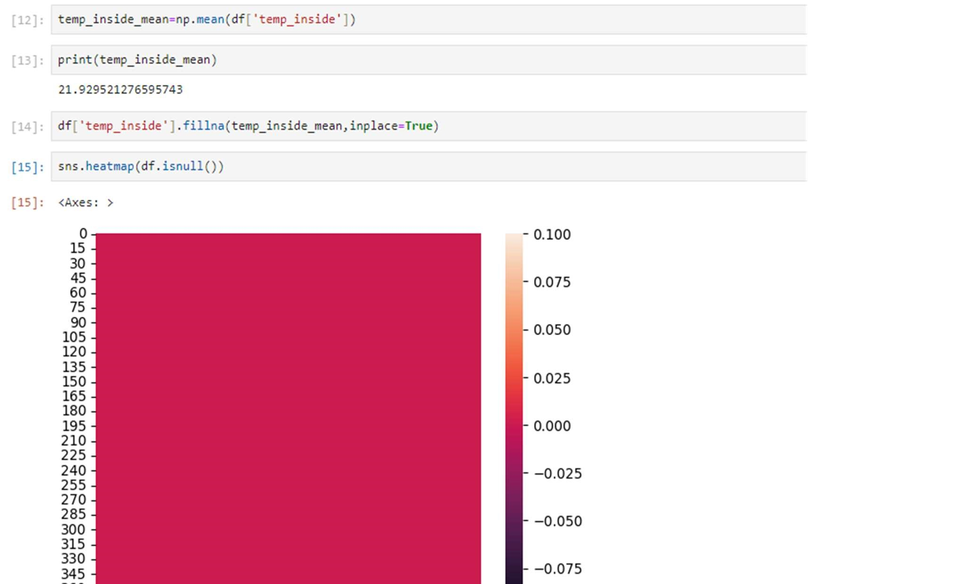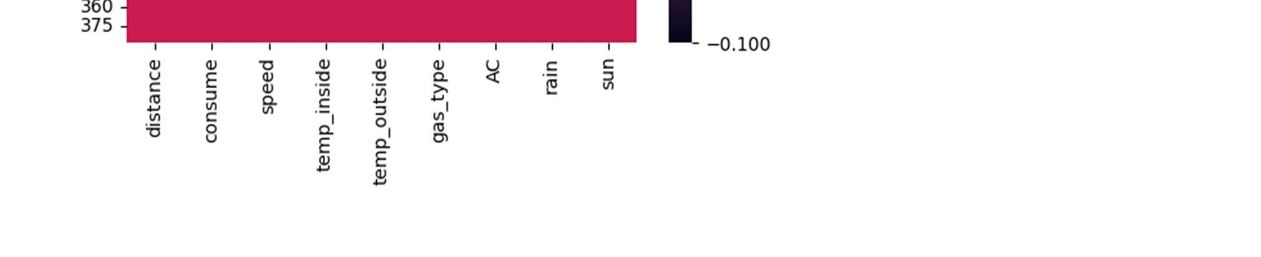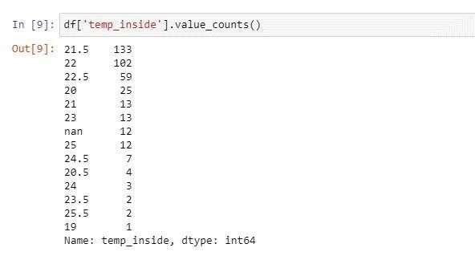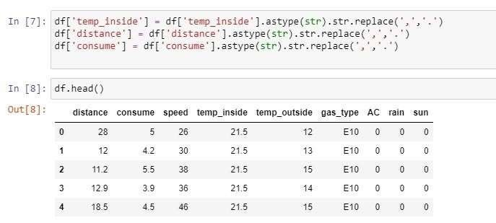

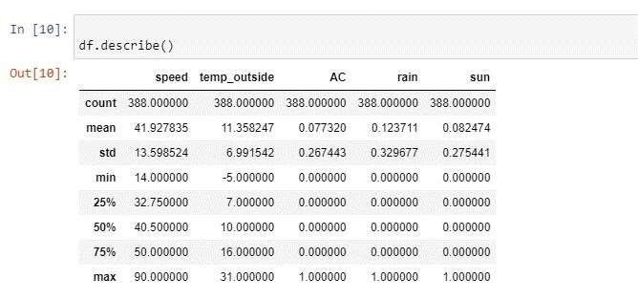

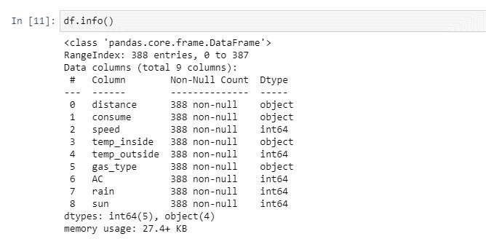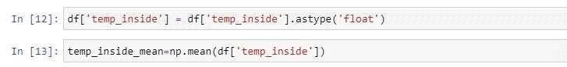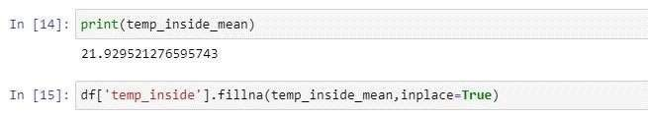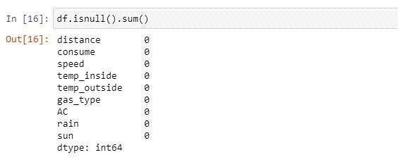

Seperating Independent And Dependent Variables

Now let’s split the Dataset into train and test sets. First split the dataset into x and y and then split the data set.

Here x and y variables are created. On x variable, df is passed with dropping the target variable. And on y target variable is passed.

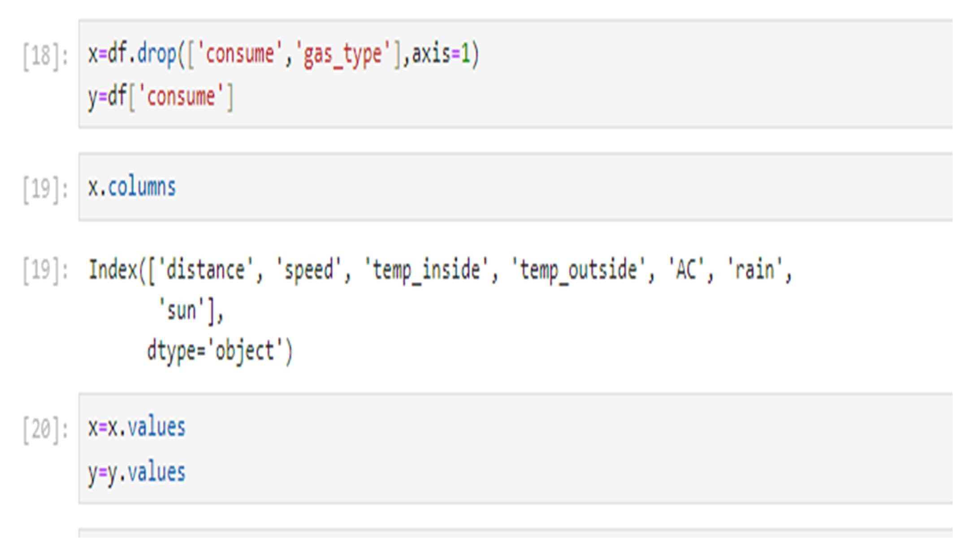

Splitting Data Into Train And Test

For splitting training and testing data we are using train_test_split() function from sklearn. As parameters, we are passing x, y, test_size, random_state.



TRAINING THE MODEL IN MULTIPLE ALGORITHMS:

1.Linear Regression:

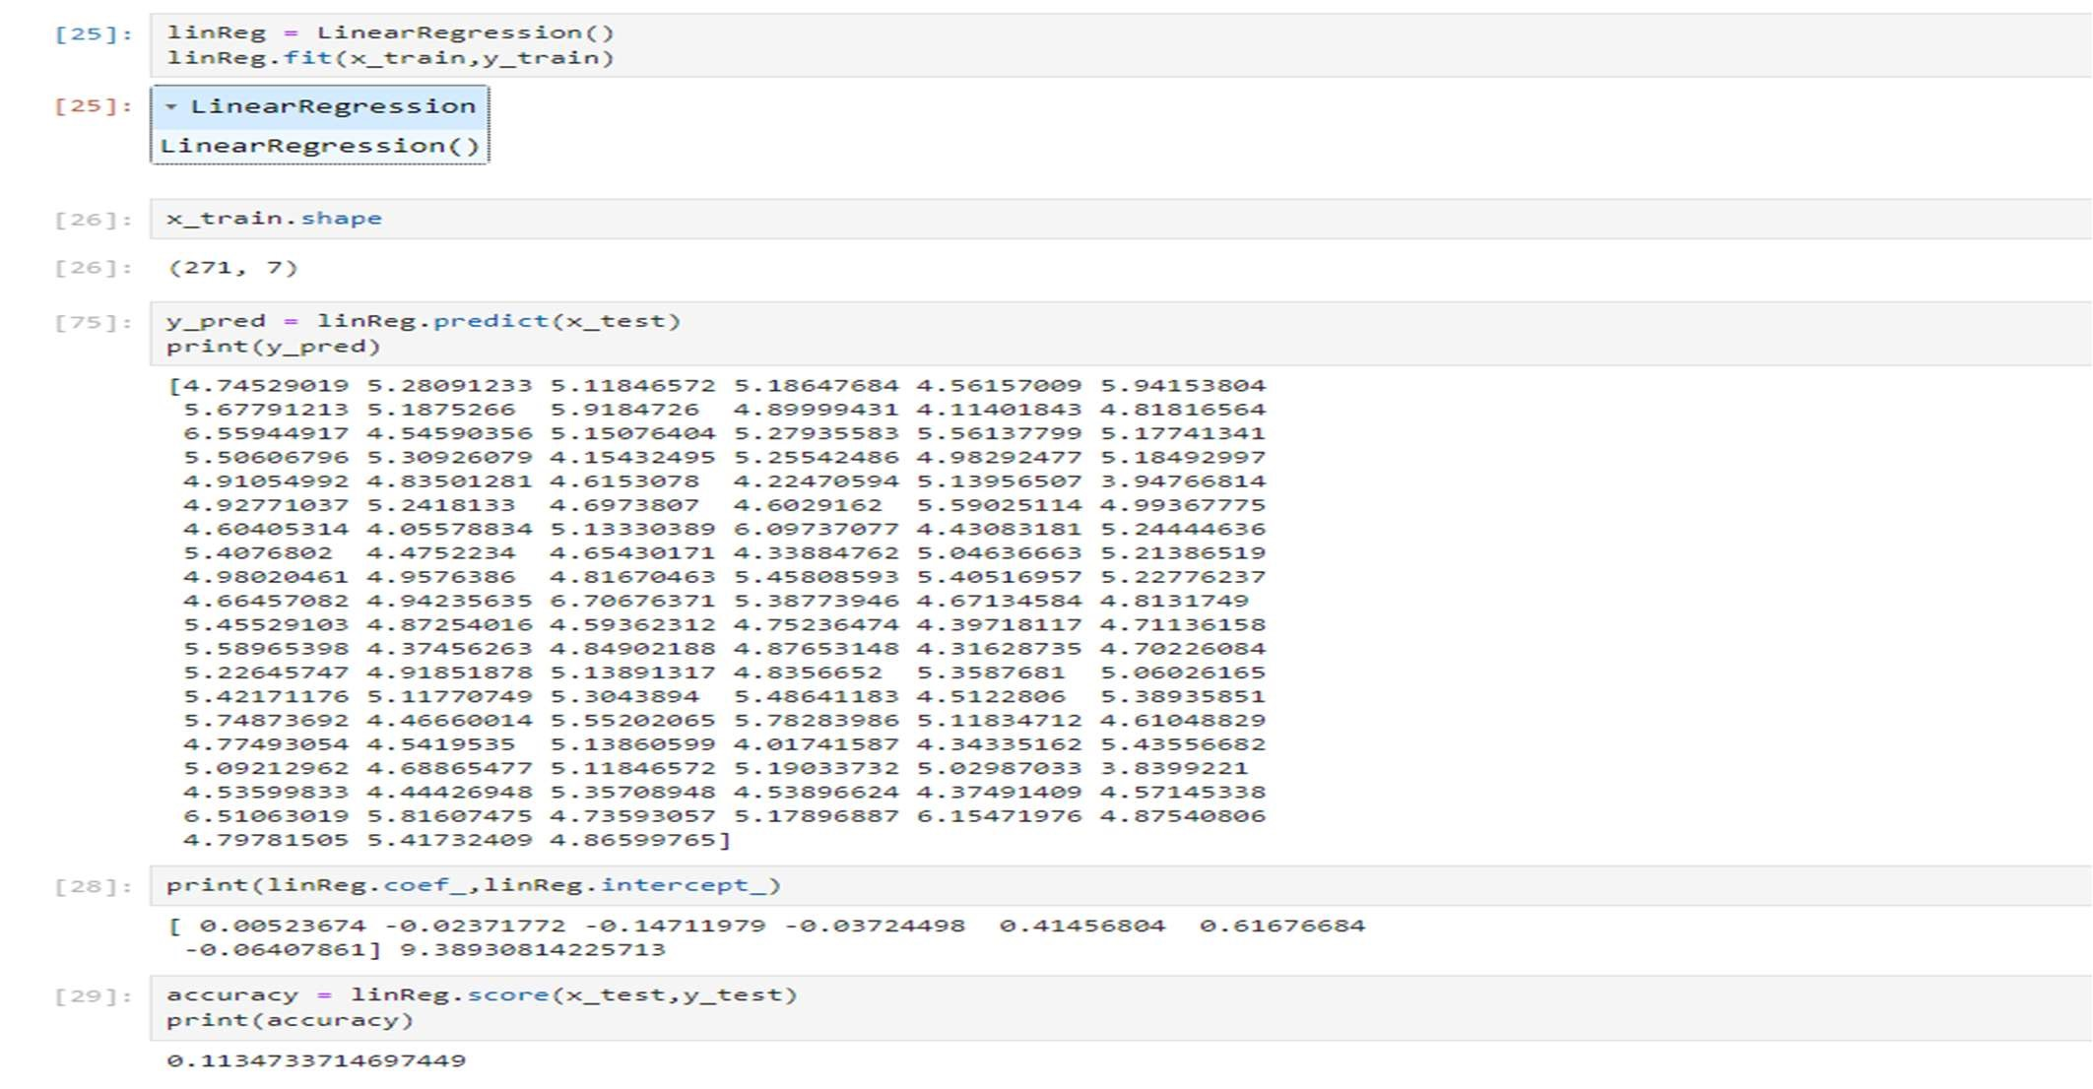

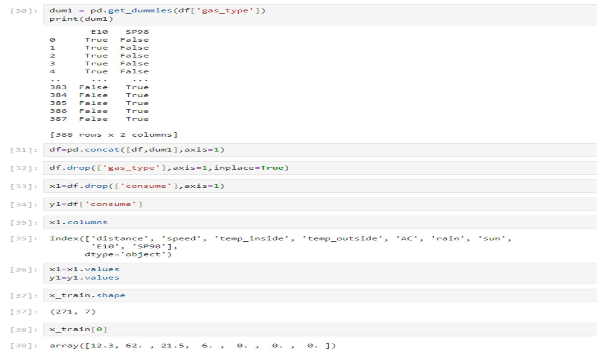

1. Lasso Regression:

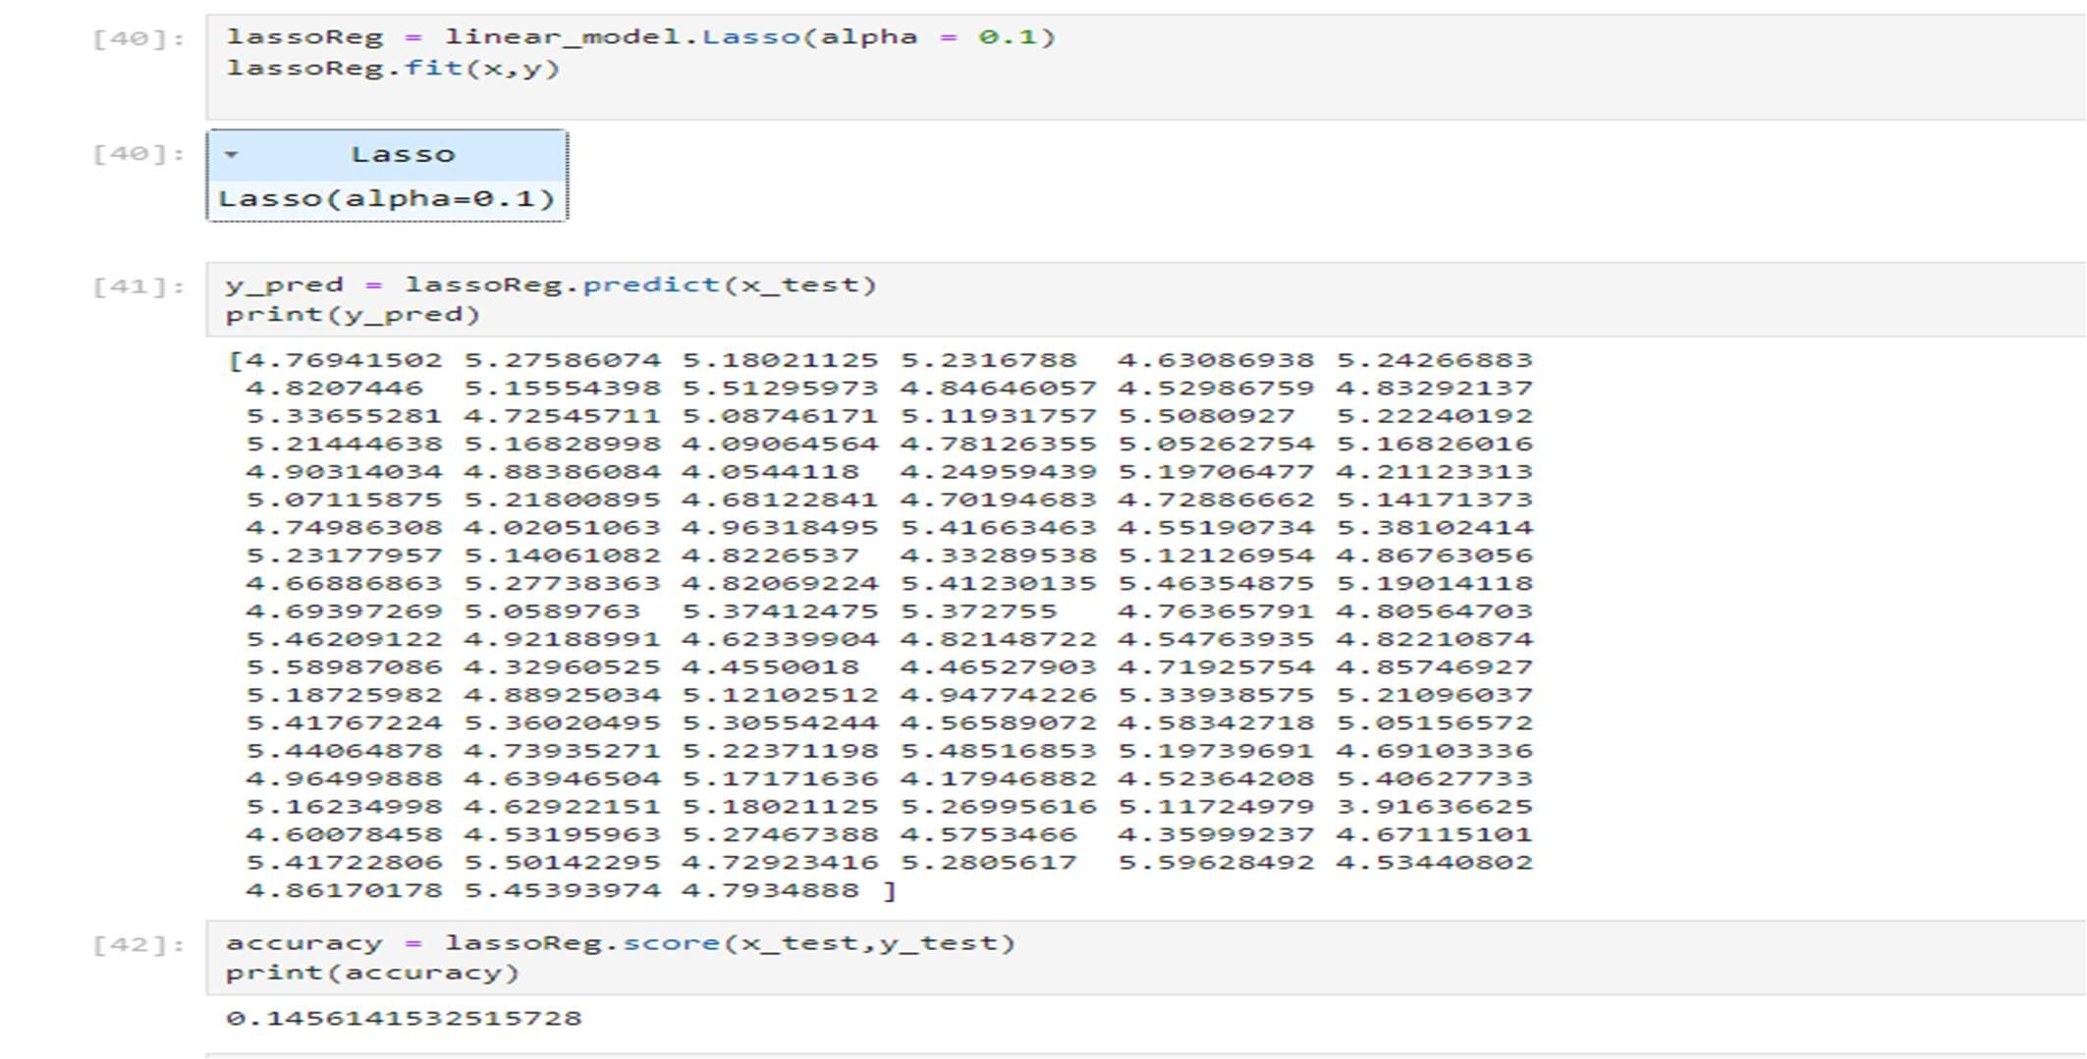

1. SVR Regression:

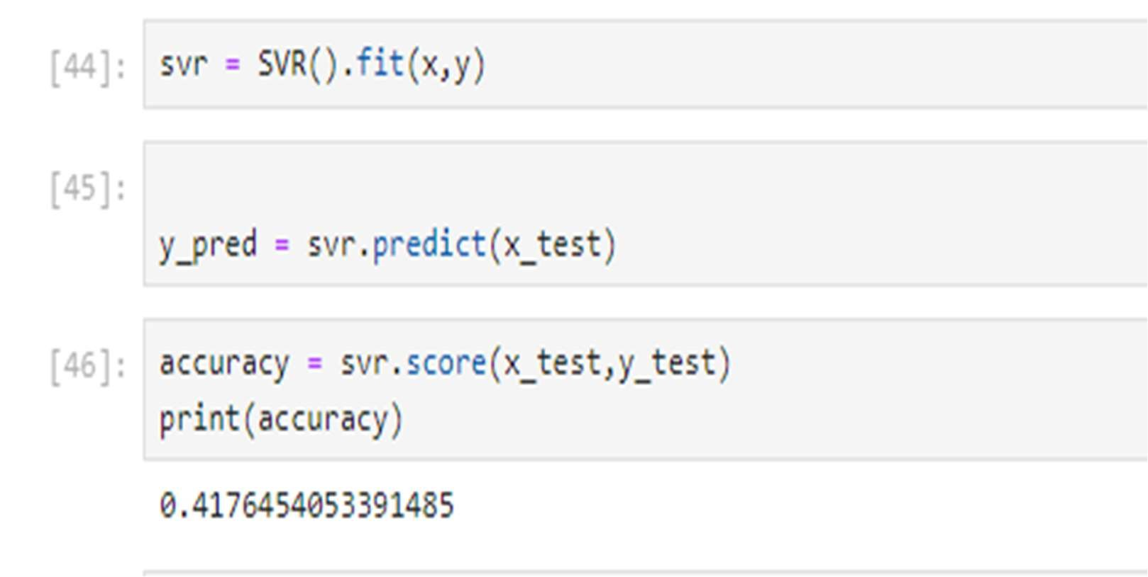

1. Decision Tree:

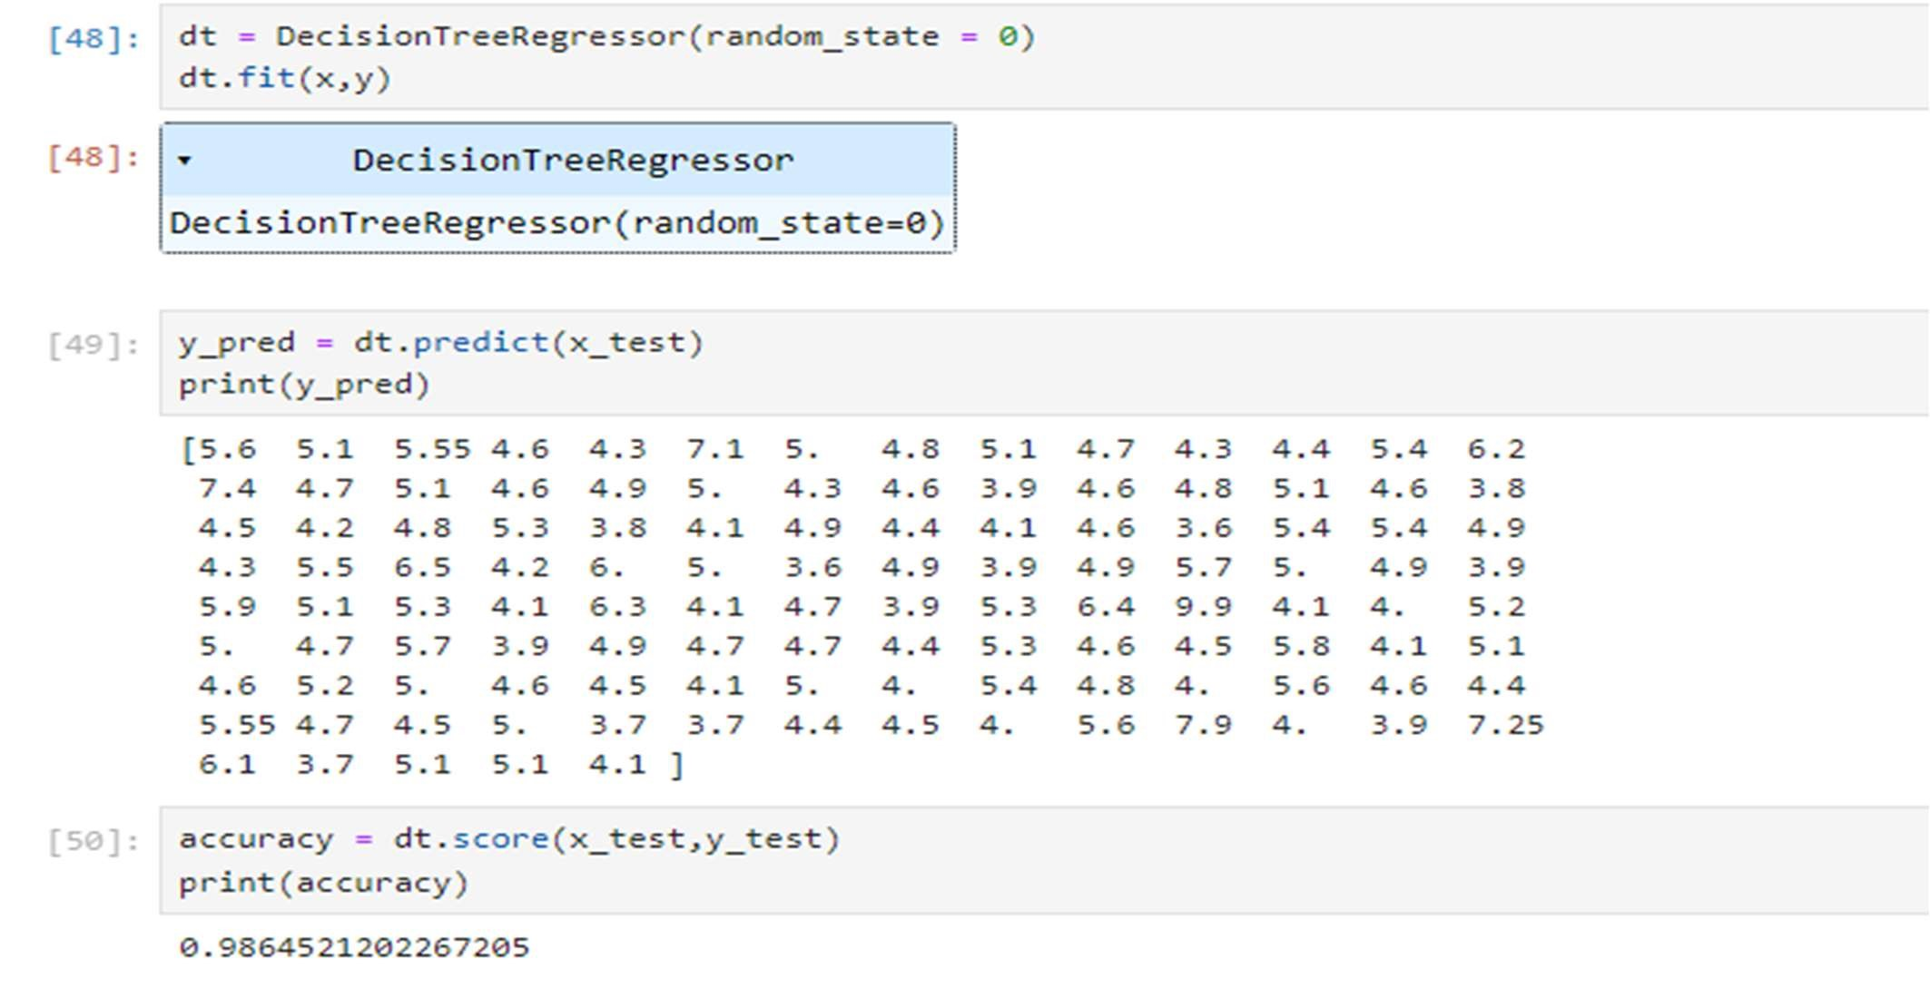

1. Random Forest:

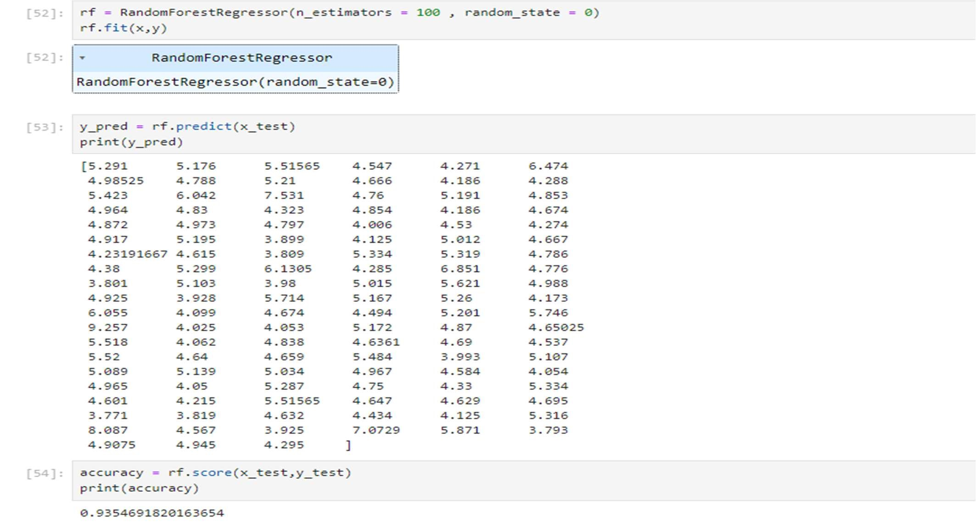

Testing All Models With Multiple Evaluation Metrics:

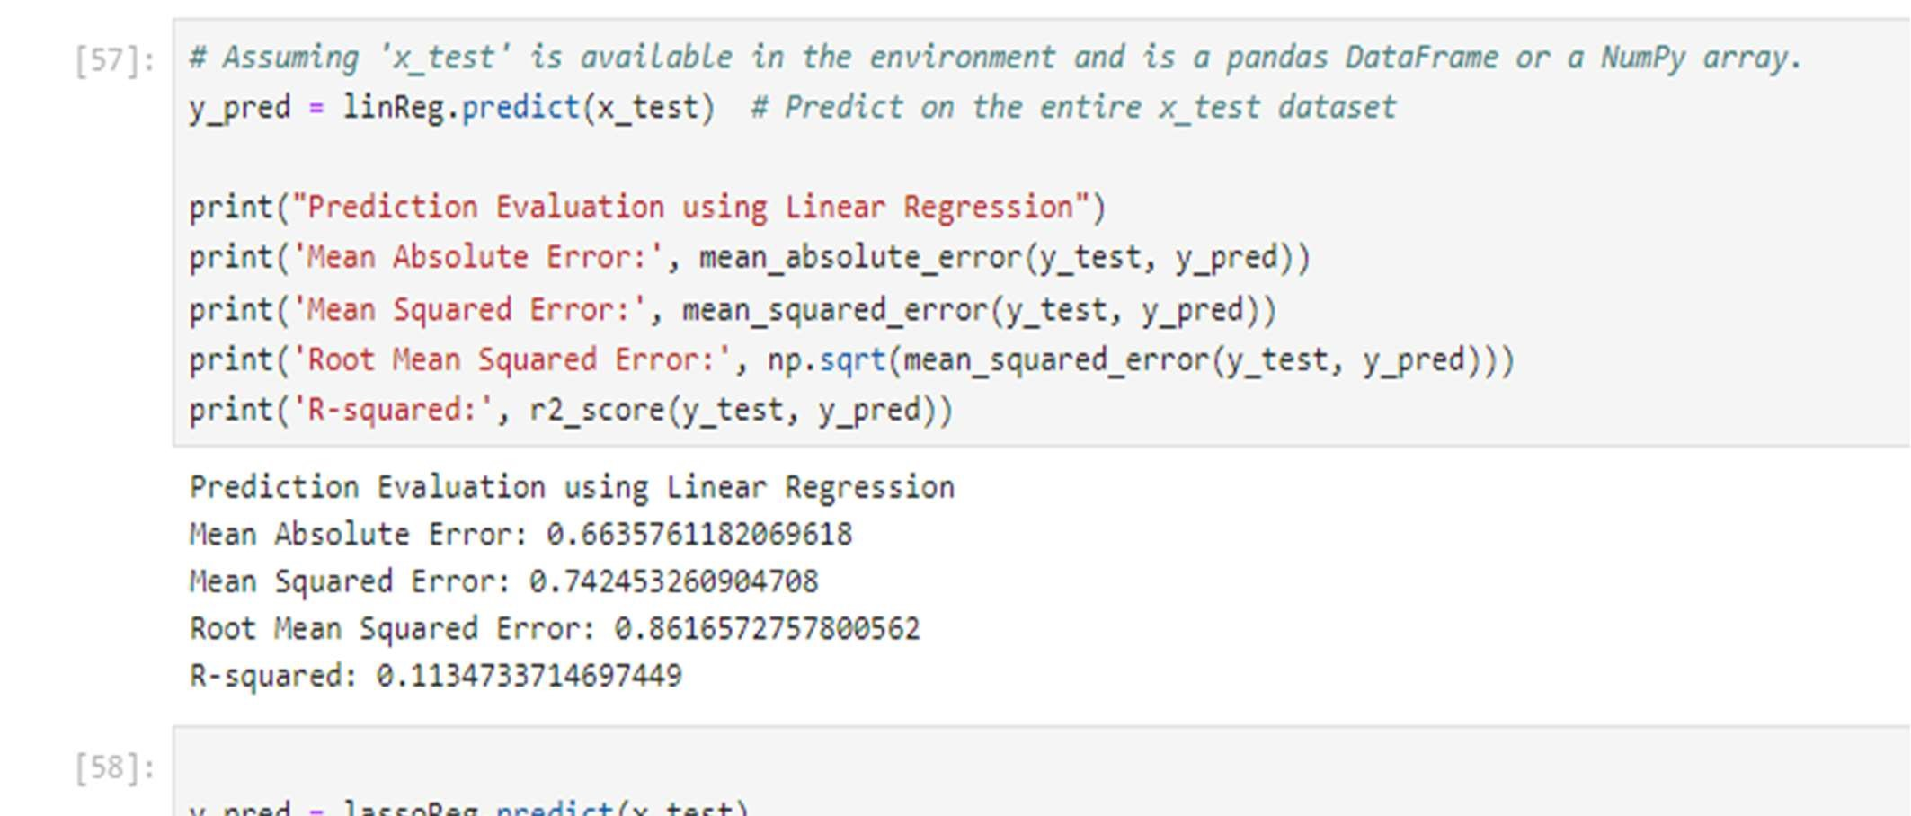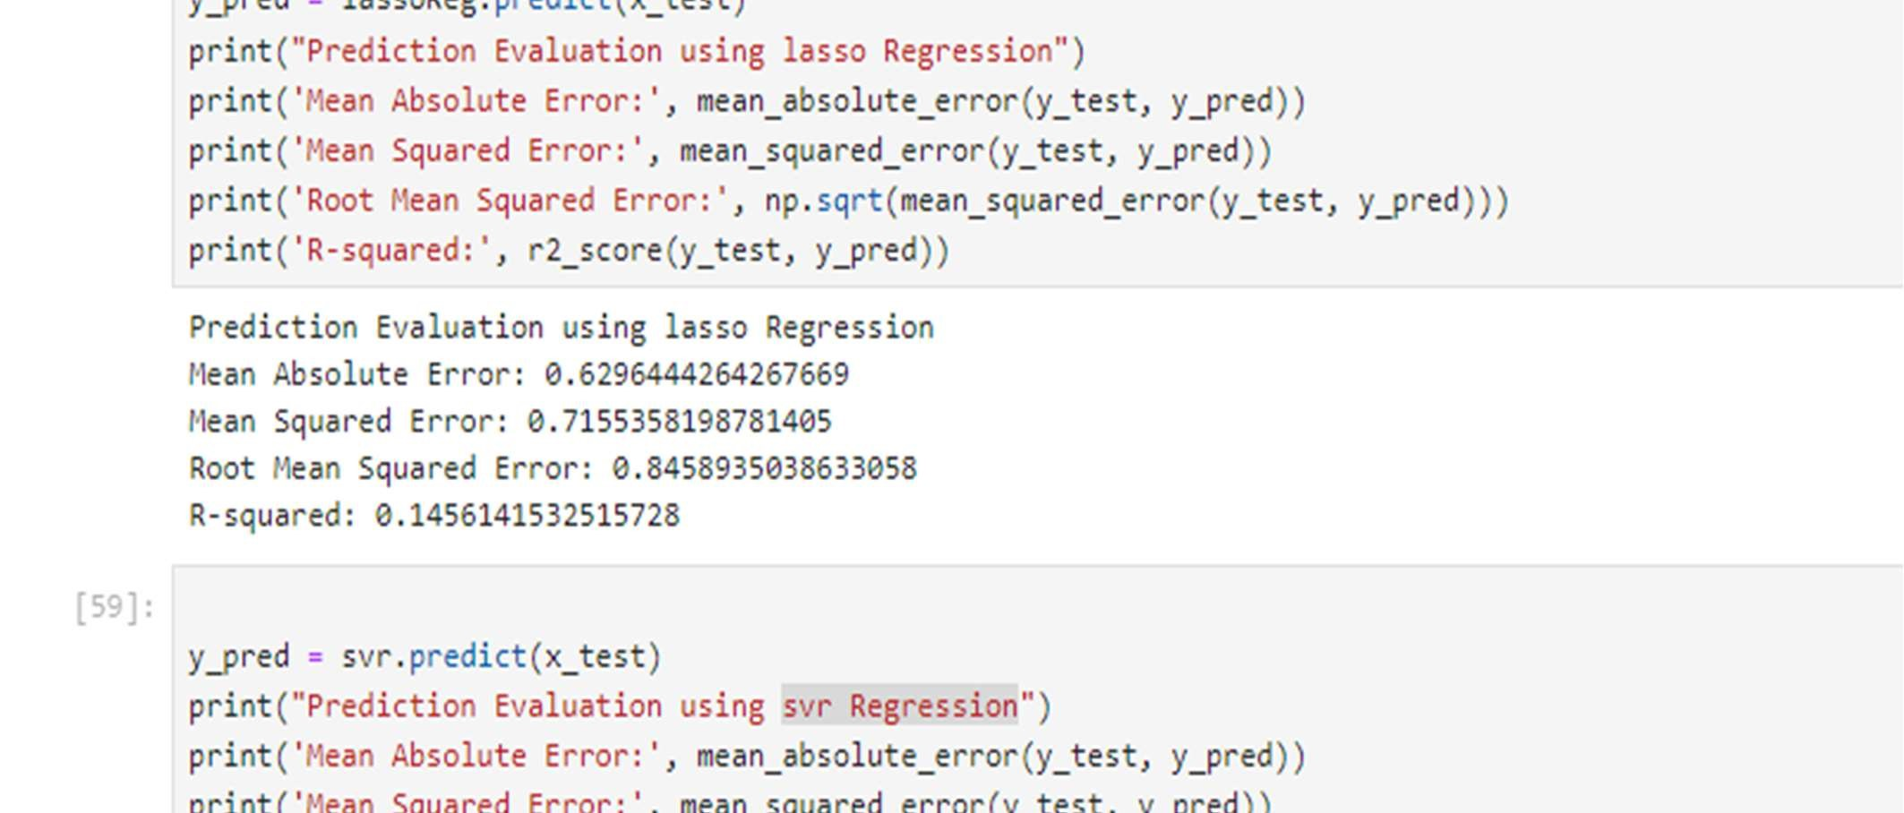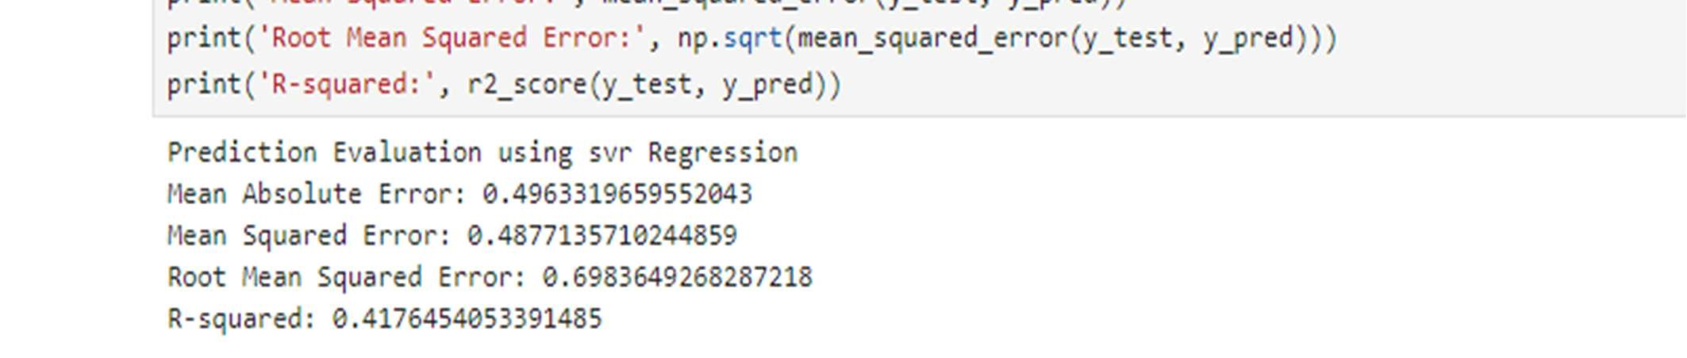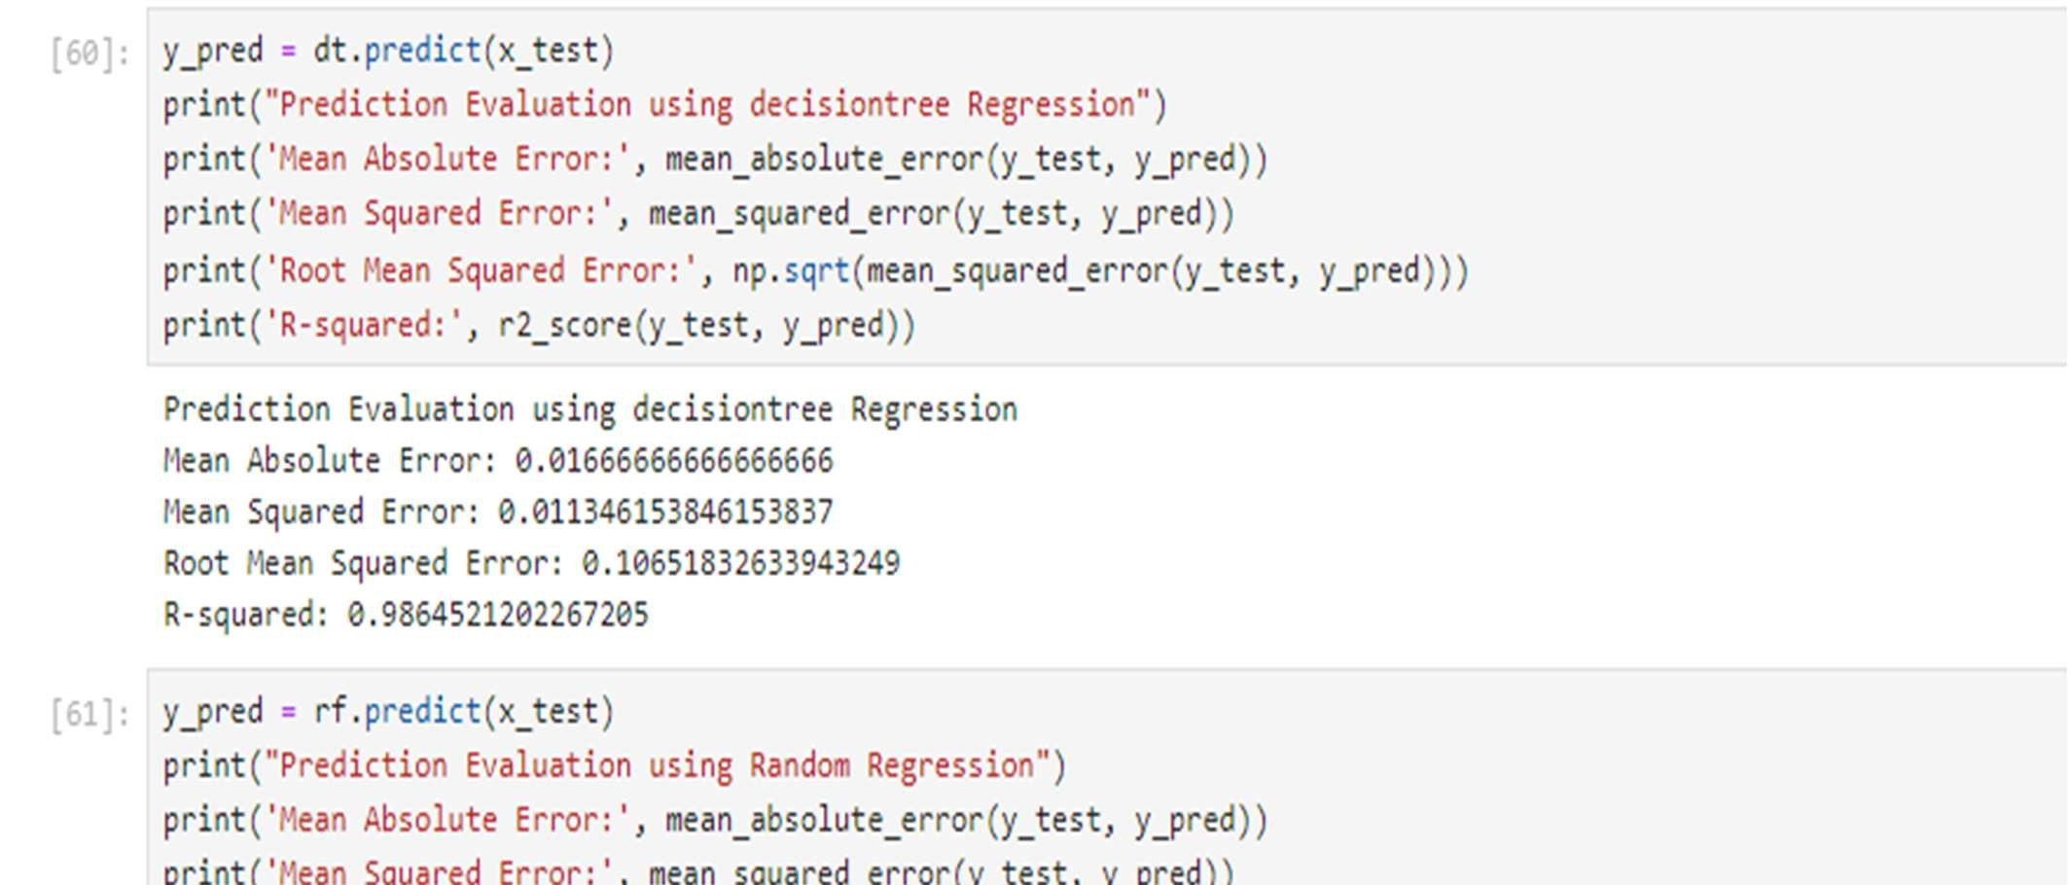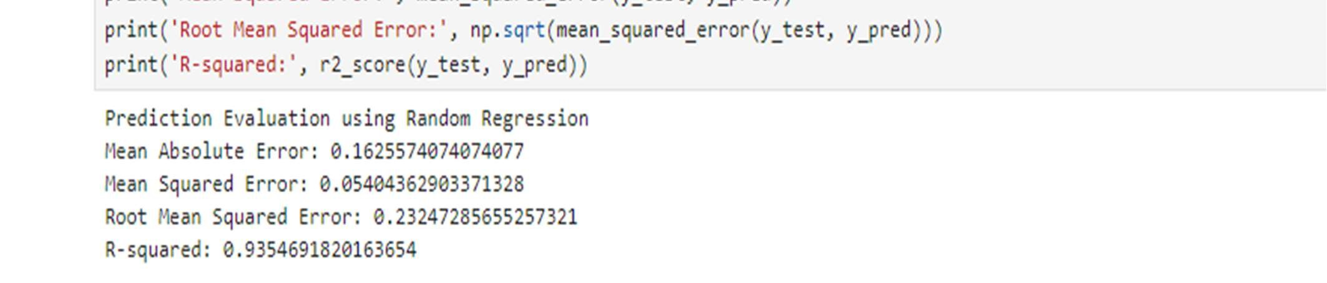

Applying Decision Tree :

Now we are going to create our model with decision tree. As an initial step we have to initialize the

decision model. Then train the model with fit() method. Now our model is trained

and to test the model

predict() method is used. To find the loss of decision tree model mean squared error

and mean absolute error are used.

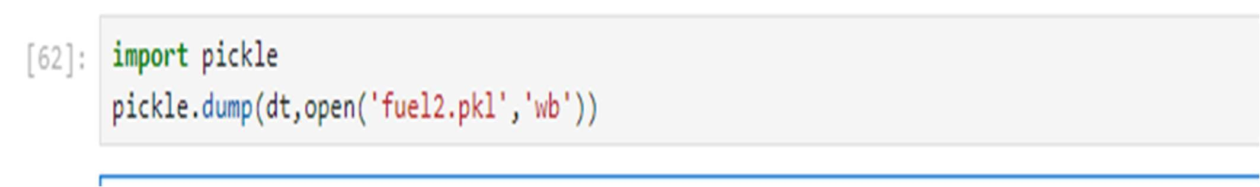

Build An HTML Page:

We Build an HTML page to take the values from the user in a form and upon clicking on the predict button we get the fuel consumption predicted.

Index.html

<!DOCTYPE html>

<html lang="en">

<head>

<meta charset="UTF-8">

<meta name="viewport" content="width=device-width, initial-scale=1.0">

<title>Fuel Predictor Website</title>

<link rel="stylesheet" href="../static/style.css">

<link rel="stylesheet" href="https://fonts.googleapis.com/css2?family=Material+Symbols+Outlined:opsz,wght,FILL,GRAD@20..48,100..700,0..1,-50..200">

</head>

<body>

<header>

<nav class="navbar">

<a href="{{url_for('home')}}" class="logo">TBFCP<span>.</span></a>

<ul class="menu-links">

<span id="close-menu-btn"class="material-symbols-outlined">close</span>

<li><a href="{{url_for('home')}}">Home</a></li>

<li><a href="{{url_for('y_predict')}}">Fuel predictor</a></li>

<li><a href="{{url_for('about')}}">About us</a></li>

<li><a href="{{url_for('contact')}}">Contact</a></li>

</ul>

<span id="menu-btn"class="material-symbols-outlined">menu</span>

</nav>

</header>

<section class="hero-section">

<div class="content">

<h1>Know your vechile's fuel consumption for a trip</h1>

<p>

For different kinds of high fleet vechiles the fuel consumption is different based on trip you take

</p>

<button><a href="{{url_for('y_predict')}}">Predict Now</button>

</div>

</section>

</body></html>

About.html

<!DOCTYPE html>

<html lang="en">

<head>

<meta charset="UTF-8">

<meta name="viewport" content="width=device-width, initial-scale=1.0"> <title>About Us page</title>

<link rel="stylesheet" href="../static/style2.css">

</head>

<body>

<section class="hero">

<header>

<nav class="navbar">

<a href="{{url_for('home')}}" class="logo">TBFCP<span>.</span></a>

<ul class="menu-links">

<li><a href="{{url_for('home')}}">Home</a></li>

<li><a href="{{url_for('y_predict')}}">Fuel predictor</a></li>

<li><a href="{{url_for('about')}}">About us</a></li>

<li><a href="{{url_for('contact')}}">Contact</a></li>

</ul>

</nav>

</header>

<div class="heading">

<h1> About Us</h1>

</div>

<div class="container">

<div class="hero-content">

<h2>Our Service</h2>

<p>We predict the fuel consumption .<br> of your vechile based on the trip you take<br> we use the machine learning model which calculate the fuel<br> based on the several parameters and provide accurate results</p>

<button class="button"> Learn more</button>

</div>

<div class="hero-img">

<img src="../static/fuelstats.jpg" alt="" width="500" height="400"> </div>

<div class="our-team">

<h2>Our Team</h2>

<p>Meet our team members who help you out<br> with the prediction of fuel consumption for your vechile </p>

</div>

<div class="team">

<ul class="team-mem">

<li>

<b>Ramya Sree Kasula</b><br>

<p>21UK1A0523</p>

<p>ramyasree.kasula1729@gmail.com</p>

</li>

<li>

<b>Akhil Boinapelli</b><br>

<p>21UK1A0521</p>

<p>akhilboinapelli@gmail.com</p>

</li>

<li>

<b>Chellamalla Manikanta</b><br>

<p>21UK1A0559</p>

<p>chellamalla.manikanta28@gmail.com</p>

</li>

<li>

<b>Bhukya Koushik</b><br>

<p>22UK5A0502</p>

<p>koushikbhukya8688@gmail.com</p>

</li>

</ul>

</div>

</div>

</section> <script> const header = document.querySelector("header"); const menuBtn = document.querySelector("#menu-btn");

const closeMenubtn = document.querySelector("#close-menu-btn");

menuBtn.addEventListener("click",() => { header.classList.toggle("show-mobile-menu");

});

closeMenubtn.addEventListener("click",() => { menuBtn.click();

});

</script>

</body>

</html>

Contact.html

<!DOCTYPE html>

<html lang="en">

<head>

<meta charset="UTF-8">

<meta name="viewport" content="width=device-width, initial-scale=1.0">

<title>Contact Us</title>

<link rel="stylesheet" href="../static/style3.css">

<link rel="stylesheet" href="https://cdn.jsdelivr.net/npm/@fortawesome/fontawesome-free@6.4.2/css/fontawesome.min.css" integrity="sha384-BY+fdrpOd3gfeRvTSMT+VUZmA728cfF9Z2G42xpaRkUGu2i3DyzpTURDo5A6CaLK" crossorigin="anonymous">

</head>

<body>

<section class="contact">

<header>

<nav class="navbar">

<a href="{{url_for('home')}}" class="logo">TBFCP<span>.</span></a>

<ul class="menu-links">

<li><a href="{{url_for('home')}}">Home</a></li>

<li><a href="{{url_for('y_predict')}}">Fuel predictor</a></li>

<li><a href="{{url_for('about')}}">About us</a></li>

<li><a href="{{url_for('contact')}}">Contact</a></li>

</ul>

</nav>

</header>

<div class="content">

<h2>Contact us</h2><br>

<p>Feel to contact us any time at your service.</p>

</div>

<div class="container">

<div class="contactInfo">

<div class="box">

<div class="icon"><i class="fa fa-map-marker" aria-hidden="true"></i></div>

<div class="text">

<h3>Address</h3>

<p>Vaagdevi Engineering college ,<br> Bollikuntaa , <br> 506002</p>

</div>

</div>

<div class="box">

<div class="icon"><i class="fa fa-phone" aria-hidden="true"></i></div>

<div class="text">

<h3>phone</h3>

<p>9160678963 <br>8919572315 <br> 8919816641 </p>

</div>

</div>

<div class="box">

<div class="icon"><i class="fa fa-envelope" aria-hidden="true"></i></div>

<div class="text">

<h3>Email</h3>

<p> ramyasree.kasula1729@gmail.com<br> akhilboinapelli@gmail.com <br> chellamalla.manikanta28@gmail.com</p>

</div>

</div>

<div class="contactForm">

<form>

<h2>Send Message</h2>

<div class="inputBox">

<input type="text" name="" required>

<span>Full Name</span>

</div>

<div class="inputBox">

<input type="text" name="" required>

<span>Email</span>

</div>

<div class="inputBox">

<textarea required="required"></textarea>

<span>Enter your Message...</span>

</div>

<div class="inputBox">

<input type="submit" name="" value="send">

</div>

</form>

</div>

</div>

</div>

</section>

</body>

</html>

Y_predict.html

<!DOCTYPE html>

<html lang="en">

<head>

<meta charset="UTF-8">

<meta name="viewport" content="width=device-width, initial-scale=1.0">

<title>Fuel predictor</title>

<link rel="stylesheet" href="../static/style1.css">

</head>

<body>

<div class="container">

<header>

<nav class="navbar">

<a href="{{url_for('home')}}" class="logo">TBFCP<span>.</span></a>

<ul class="menu-links">

<span id="close-menu-btn"class="material-symbols-outlined">close</span>

<li><a href="{{url_for('home')}}">Home</a></li>

<li><a href="{{url_for('y_predict')}}">Fuel predictor</a></li>

<li><a href="{{url_for('about')}}">About us</a></li>

<li><a href="{{url_for('contact')}}">Contact</a></li>

</ul>

<span id="menu-btn"class="material-symbols-outlined">menu</span>

</nav>

</header>

<div class="super">

<div class="main">

<div class="sub">

<h1>Fuel Consumption Predictor</h1>

<form action = "{{ url_for('predict')}}" method = "POST">

<div class="input-group">

<div class="input-field">

<input type = "number" name="dist" min="1" placeholder = "distance(km) "required>

</div>

<div class="input-field">

<input type = "number" name="speed" min="1" placeholder = "speed(km/h)" required>

</div>

<div class="input-field">

<input type = "number " name="ti" min="1" placeholder = "temparature_inside(C)" required>

</div>

<div class="input-field">

<input type = "number" name="to"min="1" placeholder = "temparature_outside(C)" required>

</div>

<div class="input-field">

<input type = "number" name="ac" min="1" placeholder = "Ac" required>

</div>

<div class="input-field">

<input type = "number" name="rain" min="1" placeholder = "rain" required>

</div>

<div class="input-field">

<input type = "number" name="sun" min="1" placeholder = "sun" required>

</div>

</div>

<div class="btn-field">

<button type="submit">Submit</button>

</div>

</form>

</div>

</div>

</div>

</div>

</body>

</html>

Result.html

<!DOCTYPE html>

<html lang="en">

<head>

<meta charset="UTF-8">

<meta name="viewport" content="width=device-width, initial-scale=1.0">

<title>result</title>

<link rel="stylesheet" href="../static/style1.css">

</head>

<body>

<div class="mini">

<header>

<nav class="navbar">

<a href="{{url_for('home')}}" class="logo">TBFCP<span>.</span></a> <ul class="menu-links">

<li><a href="{{url_for('home')}}">Home</a></li>

<li><a href="{{url_for('y_predict')}}">Fuel predictor</a></li>

<li><a href="{{url_for('about')}}">About us</a></li>

<li><a href="{{url_for('contact')}}">Contact</a></li>

</ul>

</nav>

</header>

<div class="form-box">

<div class = "result">

<h2>{{prediction_text}}</h2>

</div>

</div>

</div>

</body>

</html>

Build The Python Flask App (app1.py)

from flask import Flask, render_template, request import pickle model = pickle.load(open(r'C:\Users\akhil\OneDrive\Desktop\mini project\fuel2.pkl','rb')) app=Flask(__name__) @app.route('/') def home():

return render_template('index.html')

@app.route('/about') def about():

return render_template('about.html')

@app.route('/contact') def contact():

return render_template('contact.html') @app.route('/y_predict',methods=['POST','GET']) def y_predict():

return render_template('y_predict.html') @app.route('/result', methods=['GET','POST']) def predict():

print(request.method) if request.method == 'POST' :

x_test=[[float(x) for x in request.form.values()]] print('actual',x_test) pred=model.predict(x_test) return render_template('result.html', \ prediction_text=('Car fuel Consumption(L/100km) \

: ',pred[0]))

return render_template('result.html')

if __name__=='__main__':

app.run(debug=True)

Run The Application

Open anaconda prompt go to project folder and in that go to flask folder and run the python file by using the command “python app1.py”

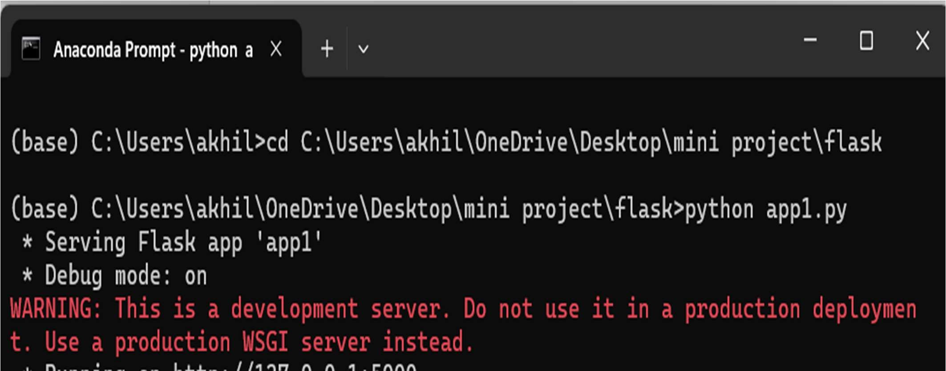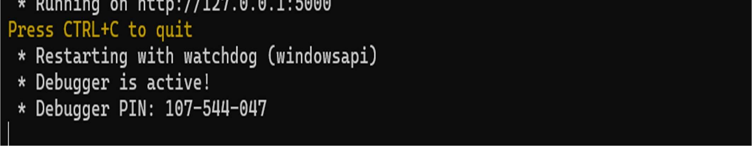

11. RESULT

HOME PAGE:

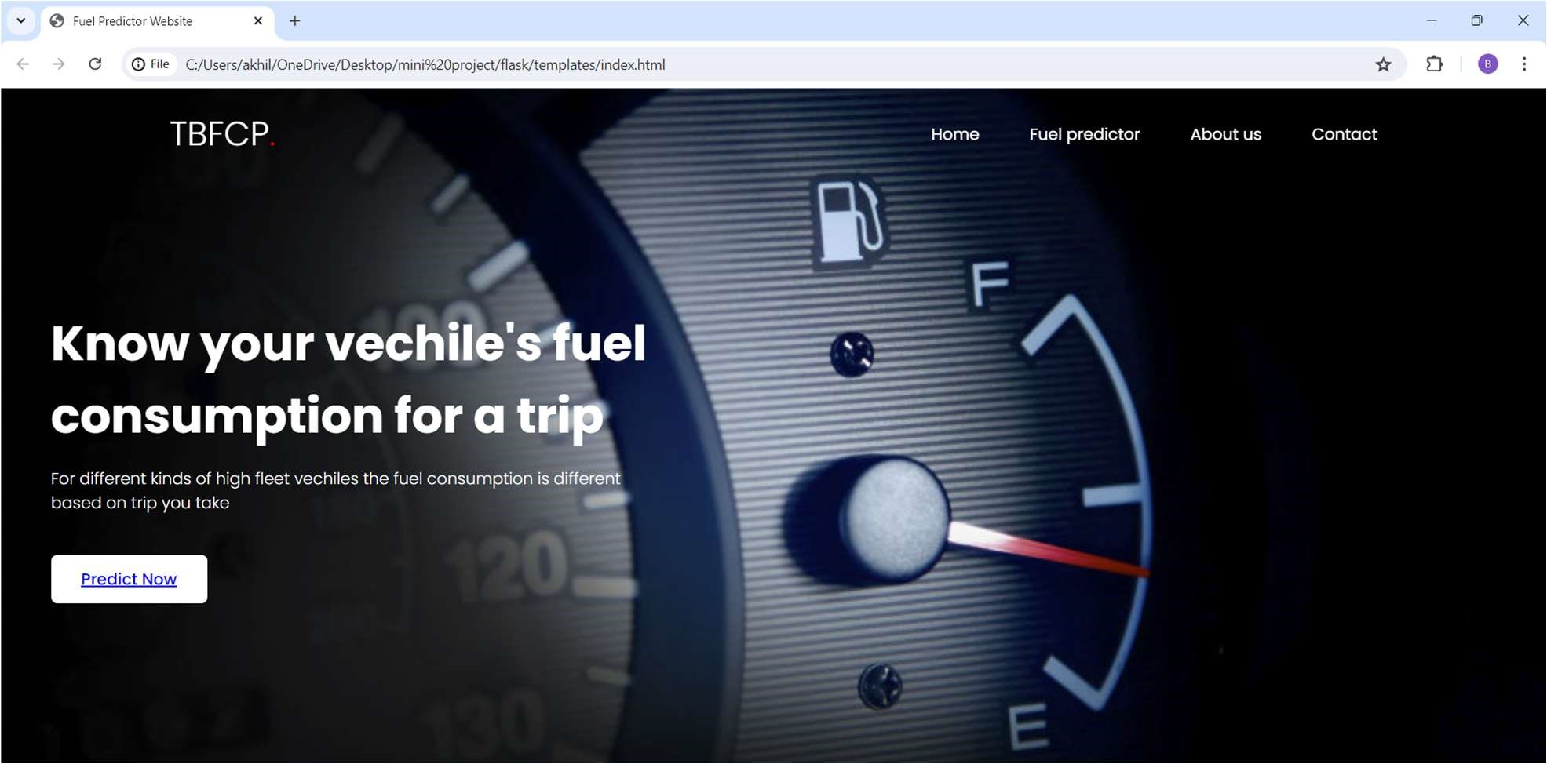

CONTACT PAGE:

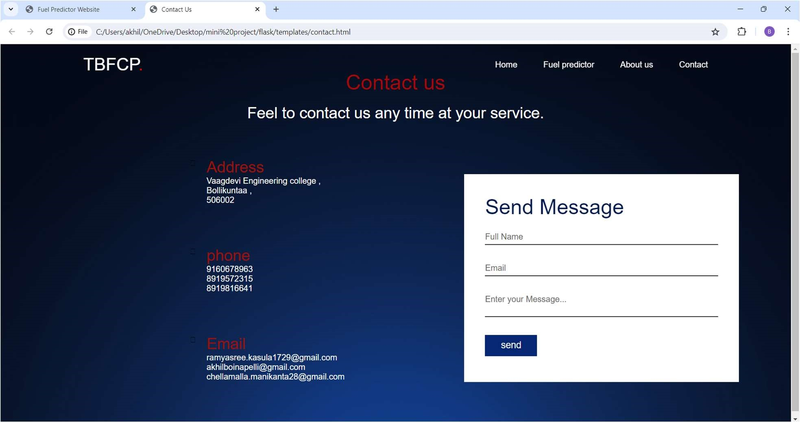

ABOUT US PAGE:

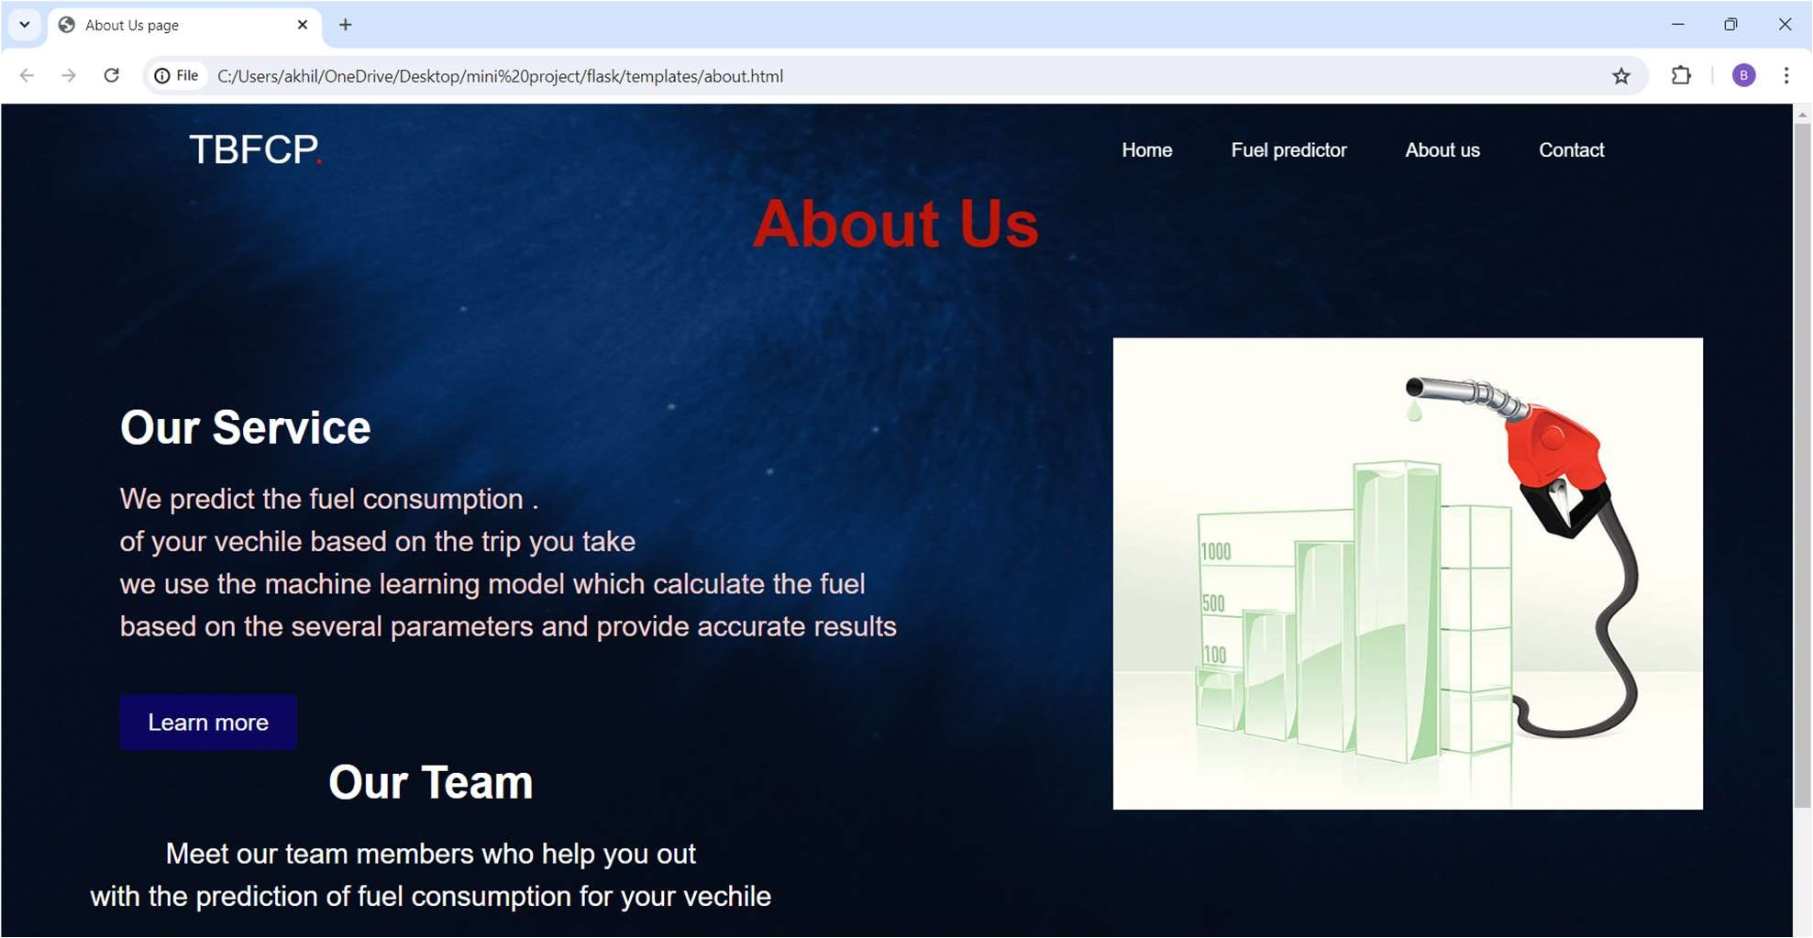

PREDICT PAGE:

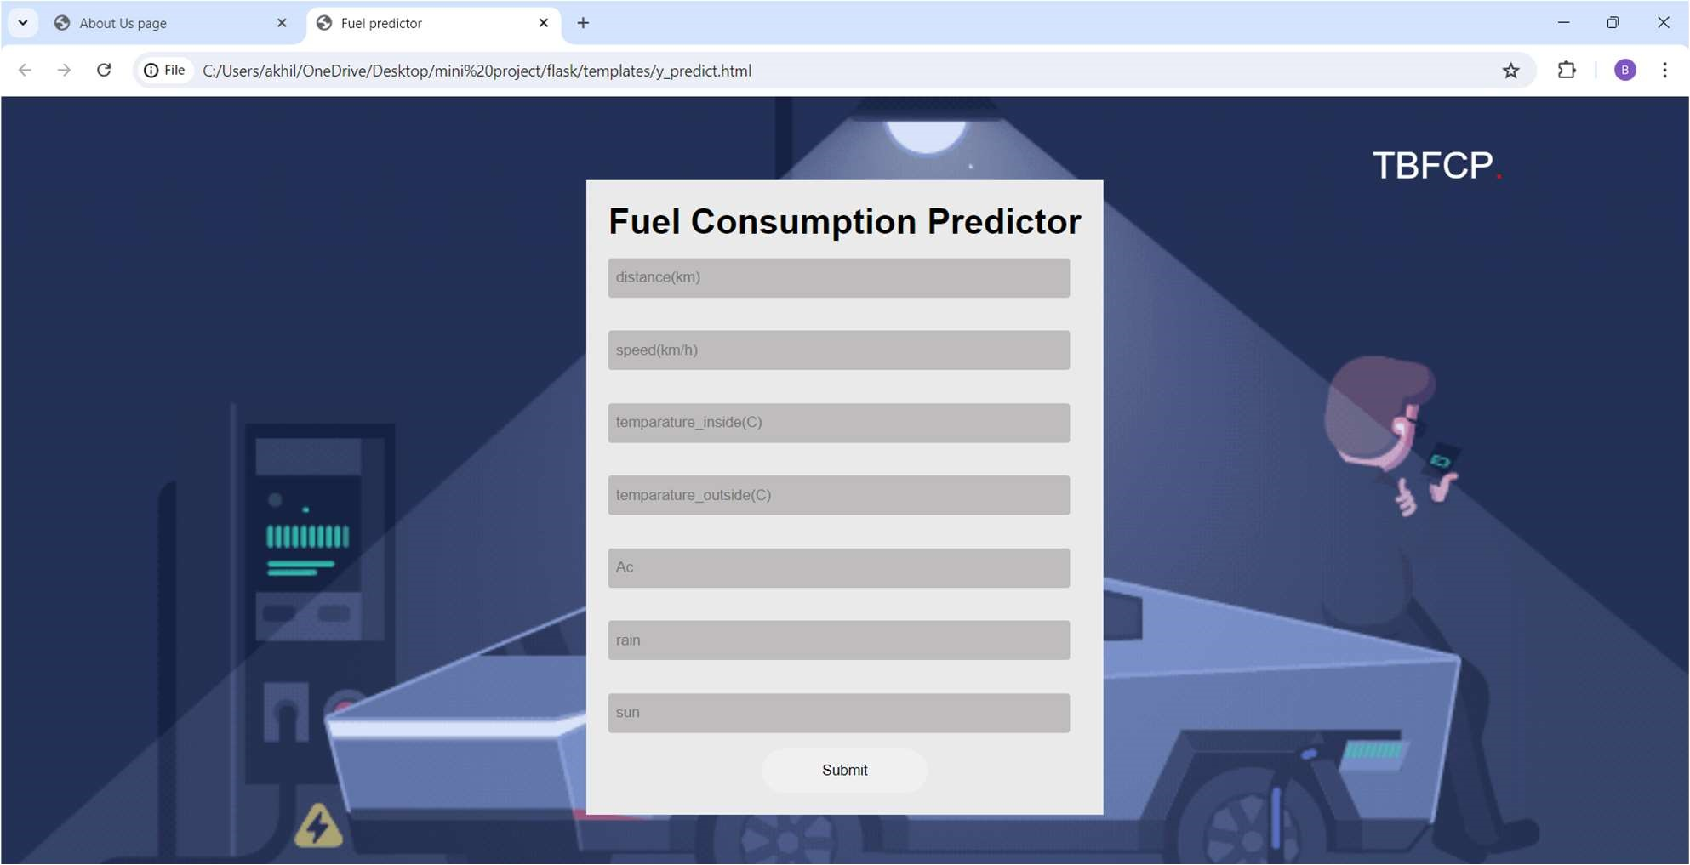

RESULT PAGE:

